Create Aws User using IAM

Attach below mention Permissions

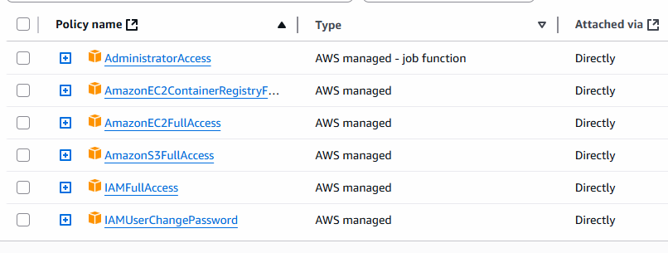

Also Create Access Keys and Secret keys

Configure AWS for executing Terraform

Set Repository Secrets

Repository 🡪 settings 🡪 Secrets 🡪 Actions 🡪 New repo Secret

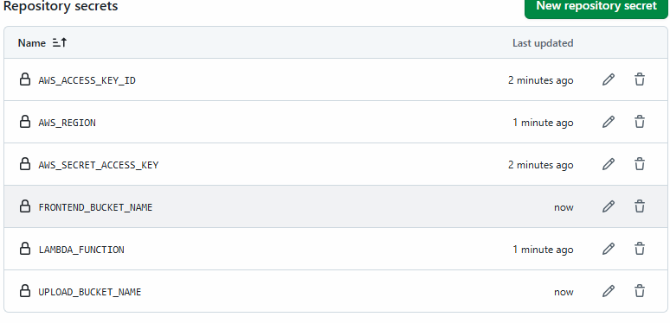

Let us Go to the code base and open wsl in your project.

Create Zip file for lambda functions

Cd backend/generate-presigned-url

zip –r lambda.zip

do it for both lambda function.

Let’s Create TfState(remote backend) Bucket

aws s3api create-bucket \

--bucket devops-accelerator-platform-tf-state \

--region us-east-1

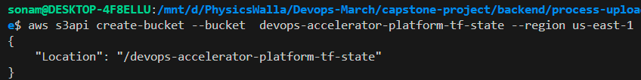

Create Dynamotable:

aws dynamodb create-table --table-name devops-accelerator-tf-locker --attribute-definitions AttributeName=LockID,AttributeType=S --key-schema AttributeName=LockID,KeyType=HASH --billing-mode PAY_PER_REQUEST --region us-east-1

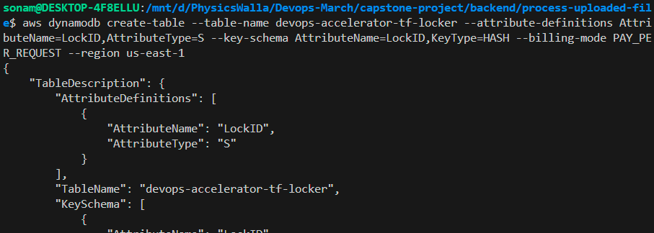

Let’s Push Thigs on Github

Then check terraform pipeline for resource creation

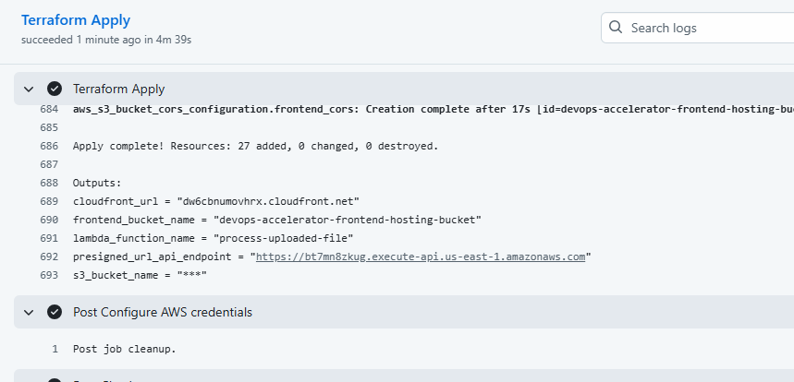

From here copy the presigned URL and paste it in your index.html file

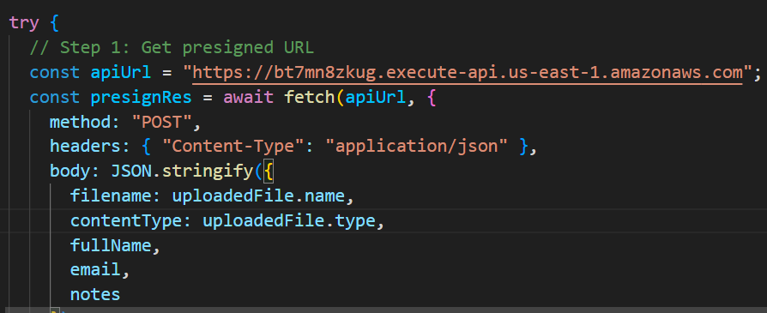

Save this file and upload it in s3 bucket.

For that open s3 bucket

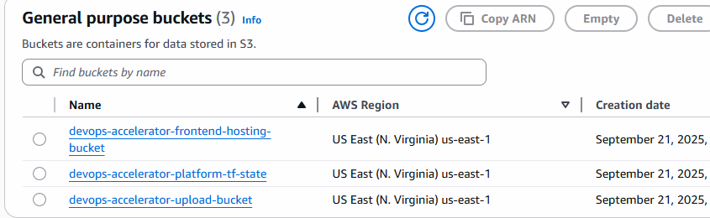

Devops-accelerator-frontend-hosting-bucket and upload index.html file there.

Now let’s check cloud front URL.

You will get below url which you can check: dw6cbnumovhrx.cloudfront.net

Below will be output if you check in browser.

